HOME
ARCHITECTS ®
MAGAZINE


© Copyright 2013 Home Architect, PLLC, All Rights Reserved Worldwide
An online e-magazine affiliated with the HOME ARCHITECTS® website.
Editor: Rand Soellner, ArCH/NCARB/LHI.
HOME ARCHITECTS ®
1 . 828 . 269 . 9046
E-mail: Rand@HomeArchitects.com
Website: www.HomeArchitects.com
This issue electronically first published on 1/2/2013, from the United States of America.

Issue 9, January 2013

Hello Clients, prospective Clients & other people interested in home architecture.

You will find a brief summary about each online article, followed by a hotlink to that article. We usually will have about 3 to 6 online articles a month, contained within the latest e-magazine issue.

Just click on the links (you may have to press your control key, then click the link) to be taken to those pages on your Internet browser. If you ever lose this e-magazine, just reopen the e-mail that contains it, or send us a request and we will promptly send you another. You may save it to your hard drive, if you wish.

If you ever think of an idea for a future story, let us know! We routinely create custom articles to answer the questions of our subscribers.

You are welcome to contact us if you have any questions (about your project or our articles): 1-828-269-9046 or Rand@HomeArchitects.com .
We hope to be your architect on your next project.

You are encouraged to forward this e-magazine along to other people.
Thank you for your interest.

Fireplaces and Hearth Rooms



Everyone who wants a new house, wants a fireplace. The HOME ARCHITECTS ® typically call the space in which the fireplace is located: the Hearth Room. Click below to discover more…

Click below to see the article:
http://www.homearchitects.com/fireplaces-and-hearth-rooms

Designing a House is Much More Than “Plans”

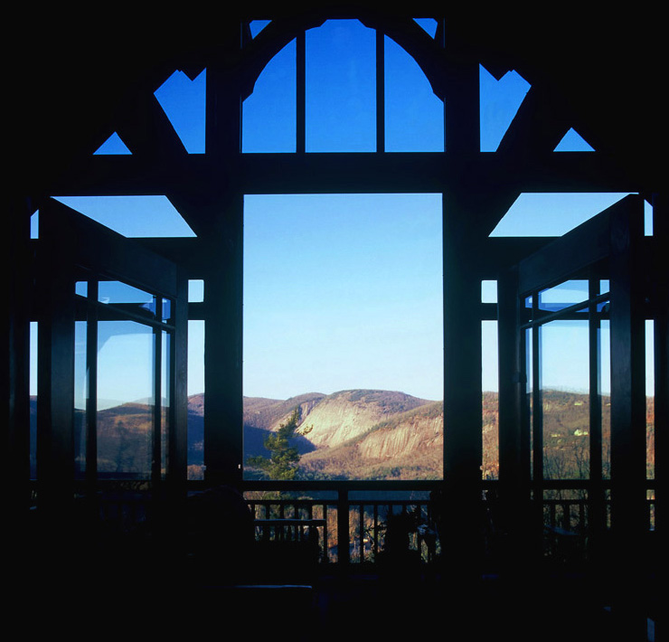

Let’s take a look at the first assumption here: the term “plans.” Some people may believe that a quick pencil sketch (not to scale) depicting general room arrangement is all they need for a builder to construct their dream house. This is not correct. Read more in the article …

Click below to see the article:
http://www.homearchitects.com/designing-a-house-is-much-more-than-plans

Weather: Frightful / House: Delightful



As winter’s foggy breath huffs over the mountains and steals into the cities and countrysides, snow, sleet, ice and harsh winds test our properties and houses. See the article to learn more…

Click below to see the article:
http://www.homearchitects.com/weather-frightful-house-delightful

ArCH Organization Founded



Rand Soellner, Senior Staff Architect of HOME ARCHITECTS ® recently co-founded “ArCH” : Architects Creating Homes. This new organization is composed of licensed architects and is dedicated to improving the practice & quality of residential architecture nationwide. Read on to find our more…

Click below to see the article:
http://www.homearchitects.com/arch-organization-founded

End of this edition.

© Copyright 2013 Home Architect, PLLC, All Rights Reserved Worldwide
HOME ARCHITECTS ®
1 . 828 . 269 . 9046
Rand@HomeArchitects.com
www.HomeArchitects.com

Anyone is hereby licensed to forward this e-magazine to anyone else, making no changes.

