HOME
ARCHITECTS ®
MAGAZINE


© Copyright 2013 Home Architect, PLLC, All Rights Reserved Worldwide
An online e-magazine affiliated with the HOME ARCHITECTS® website.
Editor: Rand Soellner, ArCH/NCARB/LHI.
HOME ARCHITECTS ®
1 . 828 . 269 . 9046
E-mail: Rand@HomeArchitects.com
Website: www.HomeArchitects.com
This issue electronically first published on 3/1/2013, from the United States of America.

Issue 11, March 2013

Hello Clients, prospective Clients & other people interested in home architecture.

You will find a brief summary about each online article, followed by a hotlink to that article. We usually will have about 3 to 6 online articles a month, contained within the latest e-magazine issue.

Just click on the links (you may have to press your control key, then click the link) to be taken to those pages on your Internet browser. If you ever lose this e-magazine, just reopen the e-mail that contains it, or send us a request and we will promptly send you another. You may save it to your hard drive, if you wish.

If you ever think of an idea for a future story, let us know! We routinely create custom articles to answer the questions of our subscribers.

You are welcome to contact us if you have any questions (about your project or our articles): 1-828-269-9046 or Rand@HomeArchitects.com .
We hope to be your architect on your next project.

You are encouraged to forward this e-magazine along to other people.
Thank you for your interest.

Top 5 House Design Trends for 2013


These are the 2013 top 5 house design trends for a specialized market: People who are at or near retirement age who are moving from urban areas to more country and suburban locations. Click below to discover more…

Click below to see the article:
http://www.homearchitects.com/top-5-house-design-trends-for-2013

3D Building Information Modeling House Design

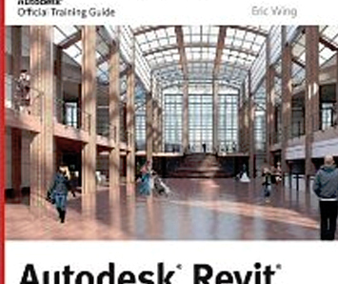

It’s typically referred to as “3D/BIM.” Three-Dimensional Building Information Modeling. Rand Soellner, Senior Staff Architect at the HOME ARCHITECTS ® is learning it. Read more in the article …

Click below to see the article:
http://www.homearchitects.com/3d-building-information-modeling-house-design

SpecNote System for House Design

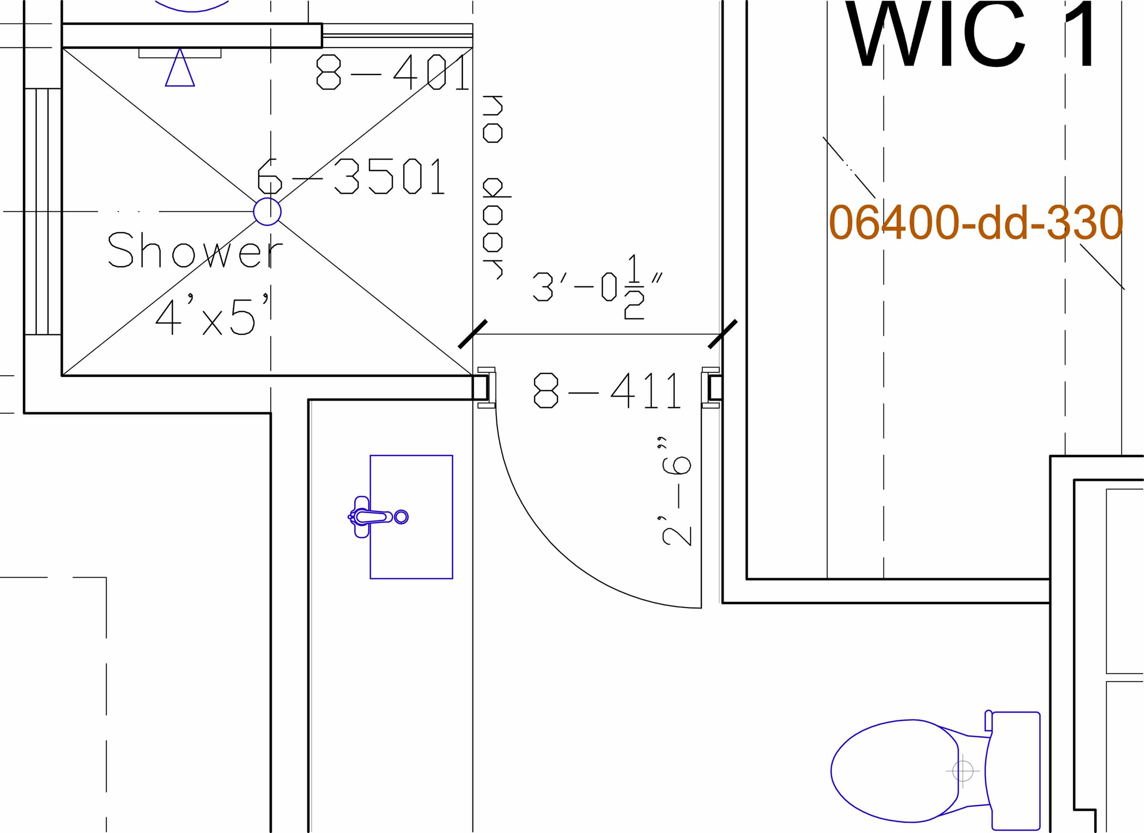

There are lots of “house designers” and even some Architects that typically do Not include specifications in their documents for a house design. In this firm’s opinion, that is not wise. Read on to find out why…

Click below to see the article:
http://www.homearchitects.com/specnote-system-for-house-design

End of this edition.

© Copyright 2013 Home Architect, PLLC, All Rights Reserved Worldwide
HOME ARCHITECTS ®
1 . 828 . 269 . 9046
Rand@HomeArchitects.com
www.HomeArchitects.com

Anyone is hereby licensed to forward this e-magazine to anyone else, making no changes.

