HOME
ARCHITECTS ®
MAGAZINE


© Copyright 2013 Home Architect, PLLC, All Rights Reserved Worldwide
An online e-magazine affiliated with the HOME ARCHITECTS® website.
Editor: Rand Soellner, ArCH/NCARB/LHI.
HOME ARCHITECTS ®
1 . 828 . 269 . 9046
E-mail: Rand@HomeArchitects.com
Website: www.HomeArchitects.com
This issue electronically first published on 1/31/2013, from the United States of America.

Issue 10, February 2013

Hello Clients, prospective Clients & other people interested in home architecture.

You will find a brief summary about each online article, followed by a hotlink to that article. We usually will have about 3 to 6 online articles a month, contained within the latest e-magazine issue.

Just click on the links (you may have to press your control key, then click the link) to be taken to those pages on your Internet browser. If you ever lose this e-magazine, just reopen the e-mail that contains it, or send us a request and we will promptly send you another. You may save it to your hard drive, if you wish.

If you ever think of an idea for a future story, let us know! We routinely create custom articles to answer the questions of our subscribers.

You are welcome to contact us if you have any questions (about your project or our articles): 1-828-269-9046 or Rand@HomeArchitects.com .
We hope to be your architect on your next project.

You are encouraged to forward this e-magazine along to other people.
Thank you for your interest.

Economical Ways to Build a House

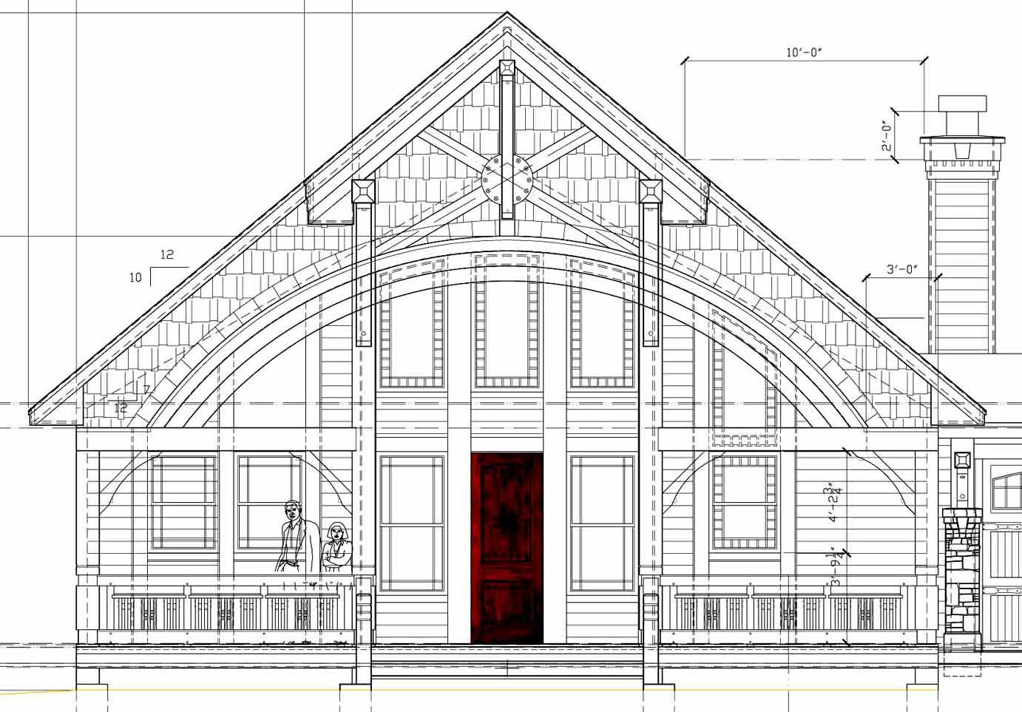

Some people might ask: “What’s the cheapest way to build a house?” Economical is probably a better
term. Click below to discover more…

Click below to see the article:
http://www.homearchitects.com/economical-ways-to-build-a-house

SunBird House Design
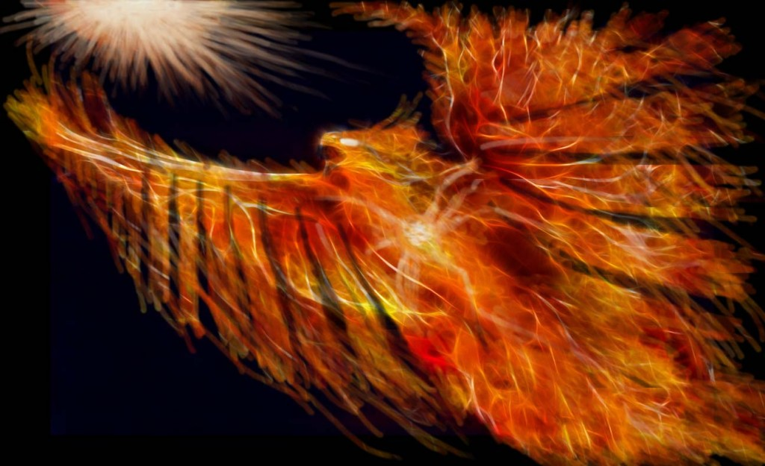

SunBird is the latest house design from the HOME ARCHITECTS ®. This is a design with lots of
options and lots of flexibility and also offers the option for Photo- Voltaic roof shingles, to allow owners to
have their electricity generated for free from the Sun. Read more in the article …

Click below to see the article:
http://www.homearchitects.com/main-menu/projects/sunbird-house-design

Roadway Access Easement to Your Land

One of the first things a licensed Architect will do during his initial Due Diligence on a project is verify how vehicular access is obtained to your land. See the article to learn more…
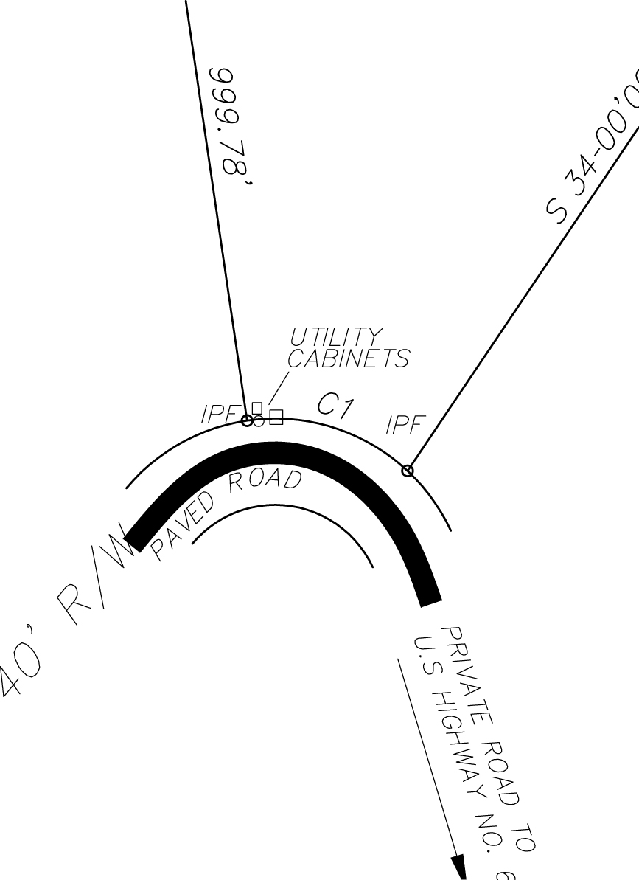

Click below to see the article:
http://www.homearchitects.com/roadway-access-easement-to-your-land

Septic System Construction Permitting



ALERT! In recent years, there has developed quite a lot of discussion and trouble with septic permits. It used to be, when you bought a piece of property that had a septic permit, you were just about guaranteed that you could later install your septic system. Unfortunately, that is no longer the case. Read on to find our more…

Click below to see the article:
http://www.homearchitects.com/septic-system-construction-permitting

End of this edition.

© Copyright 2013 Home Architect, PLLC, All Rights Reserved Worldwide
HOME ARCHITECTS ®
1 . 828 . 269 . 9046
Rand@HomeArchitects.com
www.HomeArchitects.com

Anyone is hereby licensed to forward this e-magazine to anyone else, making no changes.

